OUTPUT OF THE STUDENT JDBC PROGRAM.

- Output for a menu-driven program in JDBC for student database.

- Inserting details of a single student.
>>console:-
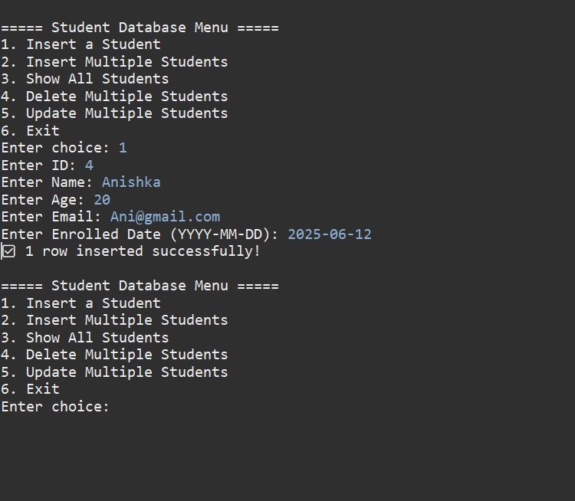

>>>Mysql command line output:-
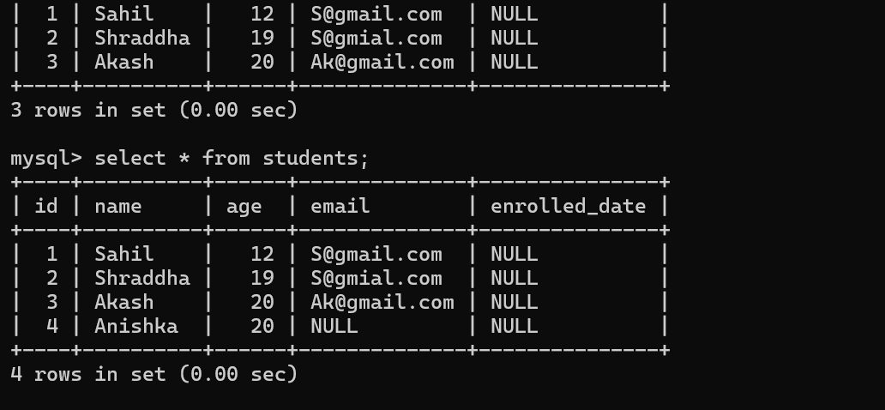

SUCCESSFULLY INSERTED!!!
2.Insert multiple student’s details.
>> console:-
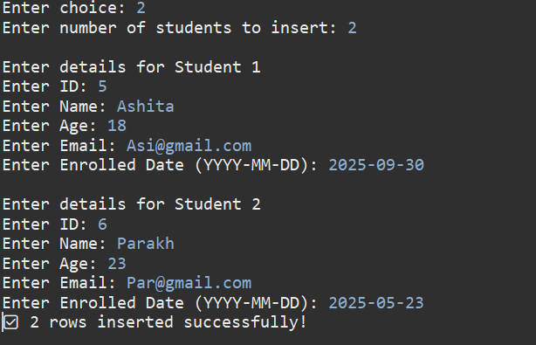
>>MYSQL COMMAND LINE
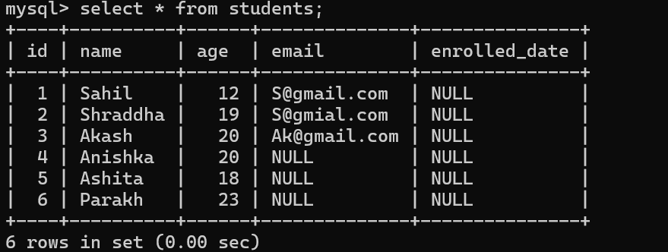
SUCCESSFULLY INSERTED 2 STUDENTS!!

3.Updating details of more than one student.
>>console:-
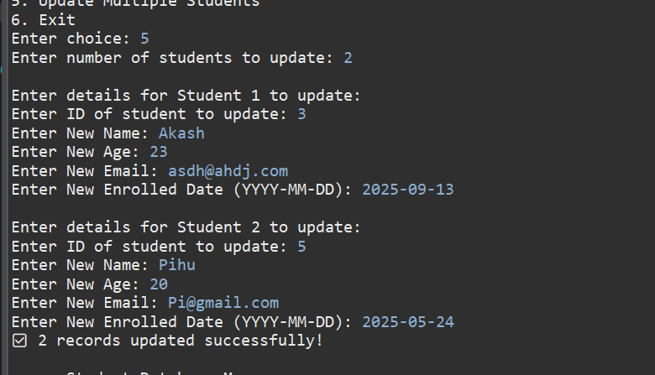

>>MYSQL COMMAND LINE:-

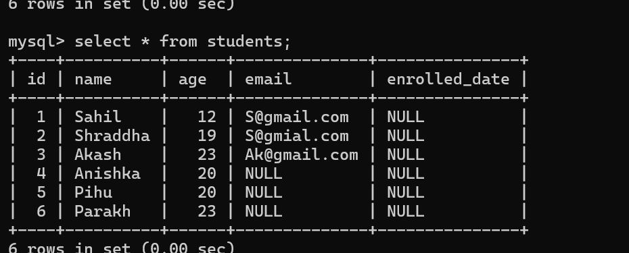
SUCCESSFULLY UPDATED DETAILS OF 2 STUDENTS!!!!
4. Delete details of multiple student.
>>console:-
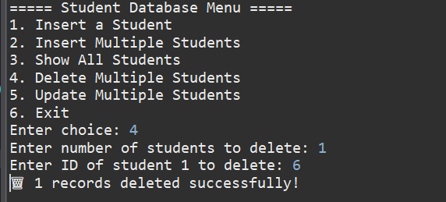
>>MYSQL COMMAND LINE:-
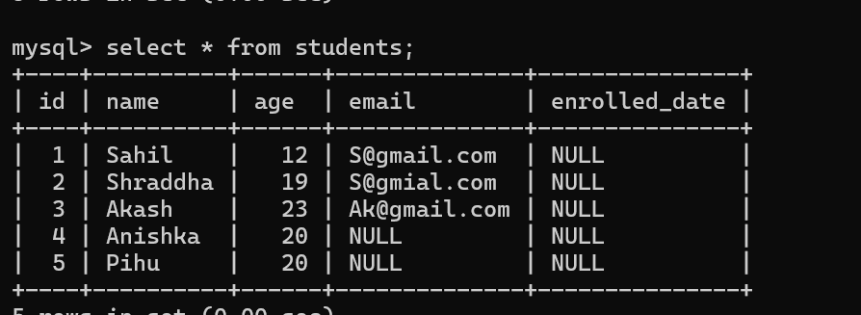

SUCCESSFULLY DELETED DETAILS OF ID=1!!!!
5.Show Students .
>>console:-
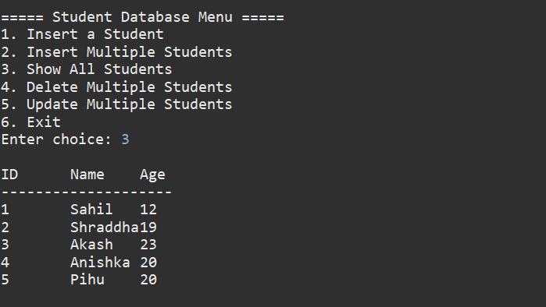
6.Exit.
